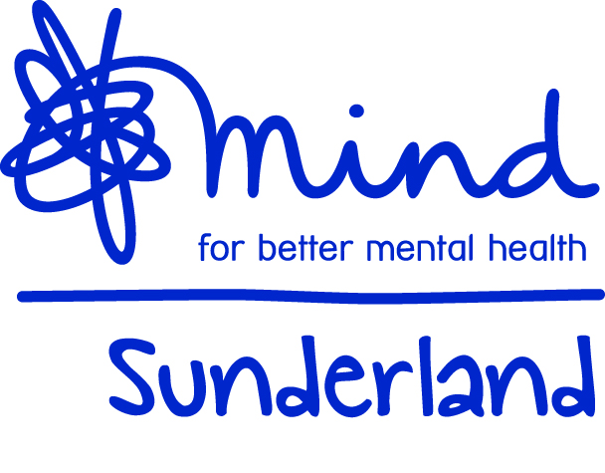
Date Received
Assessment Date

RE-ENGAGE MENTORING AND BEFRIENDING
REFERRAL FORM
DATE
CLIENT ID | (OFFICE USE ONLY)
CASE ID | (OFFICE USE ONLY)
REFERRAL AGENT

CONTACT DETAILS
(Risk assessment RA will be required from referral agent)
Please state if RA is attached or sent under separate cover

NAME
D.O.B
ADDRESS
POST CODE
EMAIL
CONTACT NUMBER
CAN A MESSAGE BE LEFT AT THIS NUMBER? |  | Yes No

NEXT OF KIN
NAME
ADDRESS

POSTCODE
CONTACT NUMBER

Can you briefly describe your personal experience of mental health problems.

Can please tick the following areas that you have difficulties with
Leaving the house |  | Being in a group
Going places on my own |  | Accessing health services
Using public transport |  | Accessing social activities
Meeting new people |  | Maintaining friendships

Someone from the service will contact you once your referral form has been received to discuss your needs in more detail.
We aim to match you with a volunteer who has similar interests or things in common. The following information will help us with the matching process.
What hobbies and Leisure Interests do you have?

How would you best describe your educational and employment background

What would you like to achieve by accessing this service?
As part of Sunderland Mind’s commitment to making diversity and equality a reality, it is our policy to ensure that all our services are open and accessible to all, regardless if it is a member of staff, volunteer or someone using our services.

The information you provide will be treated in strictest of confidence and will not be used for any other purpose other than monitoring and statistical information.
By completing and returning the monitoring form, you consent to Sunderland Mind processing this information for general monitoring purposes and statistical information in line with the diversity and equality policy.
DIVERSITY AND EQUALITY MONITORING FORM

Date of Birth:

1. Please tick the description which you feel is the most appropriate of your ethnic origin (please choose ONE section from A to F. Then tick the most appropriate box (one box only)

(A) White (C) Asian or Asian British (E) Chinese

British Indian Chinese
Irish Pakistani Other
(please state)
Other (please state) Bangladeshi
Other (please state)

(B) Mixed (D) Black or Black British (F) Any Other Background

White & Black Caribbean Caribbean Other
White & Black African African (please write in)
White & Asian Other
Other (please state) (please state)

2. How would you describe your gender? Male Female

3. Do you have a disability? Yes No

If yes, what could we do to help you in the workplace?

4. Do you identify as: Lesbian/Gay Heterosexual
Bisexual Don't wish to state

5. Religion: Christian Muslim Other
Hindu Atheist (please write in)
Sikh Buddhist
Don't wish to state Jewish

This Form will be separated from your completed Referral Form on receipt and the information it contains will NOT be used in deciding whether or not you are offered support
PLEASE RETURN THIS FORM WITH THE COMPLETED REFERRAL FORM
Client Consent and Data Protection

Sunderland Mind will use the information recorded on this form and enclosed supporting documents to enable us to provide suitable and effective support to the client. The information will be stored securely and access will be limited to those involved in providing support. We will only discuss the information with yourself, those providing you support at Sunderland Mind or the professional who referred you to the service.

Please sign below to acknowledge acceptance of the above
Client signature
Date

Please return completed forms to
The Mentoring and Befriending Service
Sunderland Mind
Sunderland
SR1 1EA.

Or email it to: reengage@sunderlandmind.co.uk.

Reg. Charity No. 510830

OFFICE USE ONLY

Client accepted to service? | YES No
If no please state reasons.

Feedback given to client? | YES No
Details of feedback given

Was the client signposted to another service? | YES NO
Details of the services signposted to

