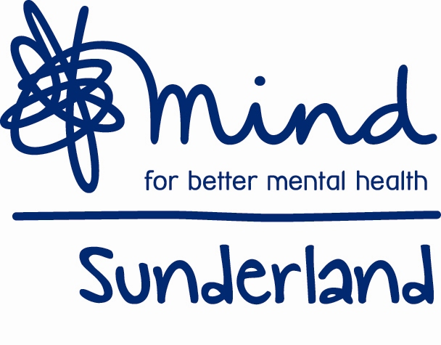
Sunderland Mind
Volunteer Application

About you:-

Position applied for: -

Name -

Address –

Telephone Number -

D.O.B –

Email –

Current Occupation –

Have you any disabilities –

Hobbies –

Interests –

In case of emergency / next of kin –

What skills or experience do you have that would benefit you in the role you are interested in?

In a few words please share why you would like to volunteer for this service

Please indicate when you would be available to volunteer for Mind…
 | Morning | Afternoon | Evening
Monday
Tuesday
Wednesday
Thursday
Friday
Saturday
Sunday

If you have any other specific requirements regarding days and times, please let us know here.

As part of being a volunteer you will need to have a DBS check (formerly CRB), we will discuss this further with you at interview

Could you please provide contact details of two personal referees.
This can be course tutors, employers or someone who knows you well

Name:

Address:

Phone number:

Email:

Name:

Address:

Phone number:

Email:

Please return this form to:

Sunderland Mind 14 Norfolk Street Sunderland SR1 1EA
Tel. 0191 565 7218

Email: volunteers@sunderlandmind.co.uk

Equality and Diversity Monitoring

Sunderland Mind aims to provide equal opportunities and fair treatment for all volunteers. Please complete the form and email or post to the address at the end. The information below is anonymous and will not be stored with any identifying information about you. All details are held in accordance with the Data Protection Act 1998.

We would like you to complete this form in order to help us understand who we are reaching and to better serve everyone in our community. The information will be used to provide an overall profile analysis of our volunteer, staff and service user base. If you would like the form in an alternative format or would like help in completing the form, please contact a member of staff.

Ethnicity
Please state what you consider your ethnic origin to be. Ethnicity is distinct from nationality and the categories below are based on the 2001 Census in alphabetical order.

Asian | Black | Chinese or other ethnic group
Indian | Caribbean | Chinese
Pakistani | African | Any other ethnic group (please write in)
Bangladeshi | Any other Black background
Any other Asian background | (please write in)
(please write in)

Mixed | White
White and Black Caribbean  White and Black African | English  Irish  Scottish | Rather not say
White and Asian | Welsh
Any other mixed background  (please write in) | Any other White background  (please write in)

Age: ______________ Rather not say

Disability
The Disability Discrimination Act 1995 (DDA) defines a person as disabled if they have a physical or mental impairment which has a substantial and long term (i.e. has lasted or is expected to last at least 12 months) adverse effect on one’s ability to carry out normal day-to-day activities. This definition includes conditions such as cancer, HIV, mental illness and learning disabilities.

Do you consider yourself to have a disability according to the above definition?

Yes No Rather not say

Gender
Male | Rather not say
Female

Faith
Which group below do you most identify with?
No religion | Baha’i | Buddhist
Christian | Hindu | Jain
Jewish | Muslim | Sikh
Other (please write in) | Rather not say

Sexual orientation
How would you describe your sexual orientation?
Bisexual | Gay man | Heterosexual or ‘straight’
Lesbian | Other | Rather not say

Today’s date:

Thank you for completing this form. Please return this form with your completed application. Once received it will then be removed and it will not influence any decision in terms of the support offered to you or any application for employment or voluntary positions.

